|  |  |
| --- | --- |
|  | **Cognizant Academy** **DREAM Theme Park Ticket Booking Automation** **HTML TechnologiesKnock Out Challenge**  **Version 1.0** |
| |  |  |  |  | | --- | --- | --- | --- | |  | **Prepared By / Last Updated By** | **Reviewed By** | **Approved By** | | **Name** |  |  |  | | **Role** |  |  |  | | **Signature** |  |  |  | | **Date** |  |  |  | |
|  |

Table of Contents

1.0 Introduction 3

1.1 Purpose 3

1.2 Definitions & Acronyms 3

1.3 Project Overview 3

1.4 Scope 3

1.5 Target Audience 3

1.6 Hardware and Software Requirements 3

1.6.1 Hardware Requirements 3

1.6.2 Software Requirements 4

2.0 Functional Requirements 4

2.1 Functional Requirements 4

3.0 Design Specification 5

3.1 UI Design 5

3.2 General Design Constraints 5

4.0 Submission 6

4.1 Code submission instructions 6

5.0 Change Log 6

# Introduction

## Purpose of this document

Dream Theme park is a famous amusement park that attracts lot of people everyday. The queue outside the ticket counter is usually long and people have to wait long to get their tickets.So in order to help their visitors save on their time and energy, the theme park wants to automate its booking process so that the visitors can book the tickets online from the official website. All the visitors need to do is log on to the website and provide their details.

Dream Theme Park Automation wants to design a web page for the ticket booking that requires the visitors to provide their details. Create a Web page “Book Your Tickets” that has the following fields such as name, address, email, mobile number along with the location of the theme park, date of visit and number of people visiting the theme park.  Also booking type needs to be entered.  It can be either Normal or School or Corporate. The styles have to be applied using CSS3 and the Ticket amount validated and displayed in Javascript.

1.2Definitions & Acronyms

|  |  |
| --- | --- |
| Definition / Acronym | Description |
| Nill |  |
|  |  |
|  |  |
|  |  |

## Project Overview

This project enables to implement the concepts of Web technologies such as HTML5, CSS3 and Javascript, and helps to acquire the skills required by aWeb designer. The HTML5, CSS3 and Javascript requirements are given precisely so that the associate can implement the various concepts learned in all these web technologies,The individual associate is expected to carry out the knock out challenge and complete it within 2 hours.

## Scope

The scope of the Dream Theme Park Automation is focused on the following

1. Designing a Web page “Book Your Tickets” with the specified fields.
2. Applying the styles using CSS to the components.
3. Using JavaScript for calculating the total amount of tickets

## Target Audience

Learner Level

## Hardware and Software Requirements

### Hardware Requirements

|  |  |  |
| --- | --- | --- |
| # | Item | Specification/Version |
|  |  |  |
|  |  |  |
|  |  |  |

### Software Requirements

|  |  |  |
| --- | --- | --- |
| # | Item | Specification/Version |
| 1. | HTML | 5 |
| 2. | CSS | 3 |
| 3. | Javascript |  |

Note: All the required hardware and software will be provided in the TekStac platform

# Functional Requirements

## Functional Requirements

|  |  |  |
| --- | --- | --- |
| Req. # | Req. Name | Req. Description |
| 1 | Design a Web page “Book Your Tickets” with the specified fields. | |  |  |  | | --- | --- | --- | | Label Name | Component  Name | Description | | Customer Name | customerName | To enter the name of the customer.  **The name should accept only letters and space.**  **The text “Enter your name” should be displayed by default in the text box. When the user starts entering the value, this text should disappear.** | | Address | Address | To enter the address of the customer.  **Provide the correct tag and attribute to create a text area with  5 rows and 20 columns.** | | Email ID | customerEmail | To enter the email of the customer.  **This field should accept a valid email.** | | Mobile Number | customerMobileNumber | To enter the mobile number.  **The mobile number should accept only digits.  It should contain 10 digits and start with 9/8/7.** | | Park Location | location | Select the Park location.  **Provide the correct input type to make this component a radio button.** | | Date of Visit | dateofvisit | To select the date of visit. | | Booking Type | bookingType | An auto-complete feature should be available to the user for the following options.  **Normal, School, Corporate**  **(Name of the auto-complete feature should be “bookType”; Use DataListto, make use of auto-complete feature)** | | Adult | adults | To enter the number of adults.  **Provide the input type so that this field accepts only digits.**  **Set minimum value as 0 and maximum value as 500. Have the id attribute as adult.** | | Children | children | To enter the number of children.  **Provide the input type so that this field accepts only digits. Have the id attribute as children.** | | Book Now | submit | The input type submit must be used. | | Clear | reset | Reset Button.  On clicking this button, all fields should be reset.  Provide the input type for this component. |    NOTE: The text highlighted in bold in the Description needs to be implemented in the code to complete the web page design. Use the Label Name and the Component Name as given  All validations should be based on HTML 5 (Do not use Javascript). All the fields are mandatory |
| 2 | Apply the mentioned styles using CSS to the components. | 1.       Body color should be “#FFAACC”.  2.       The heading should be done using <h1> tag, the text color should be “#770080”, font should be “Courier New”, style should be “italic” and it should be aligned to center of the webpage.  3.       The result should be bold and color of the text should be #770080  Note: Fill in the  style tag so that the given styles are applied to the components.  (Do not use Inline CSS) |
| 3 | Use JavaScript for calculating the total amount of tickets | Use JavaScript for doing the following calculation:  Customer on entering the valid values and clicking the submit button the total amount should be calculated based on the assumptions given:   * Ticket cost per Adult : Rs. 1500 * Ticket cost per Child : Rs. 1200 * If Booking Type is Normal, no discount is provided. * If Booking Type is School, 50% discount is provided on the total ticket cost * If Booking Type is Corporate, 25% discount is provided on the total ticket cost   Hence Total cost = Total Ticket Cost  -  discount  The result needs to be  displayed as  “**Thank you customerName. Total cost to be paid is ………”  in a div tag  with   id  “result**”.  **Note: Use getElementsByName or getElementById function to retrieve the values** |

# Design Specification

## UI Design

* + - 1. The Sample web page should look as follows,

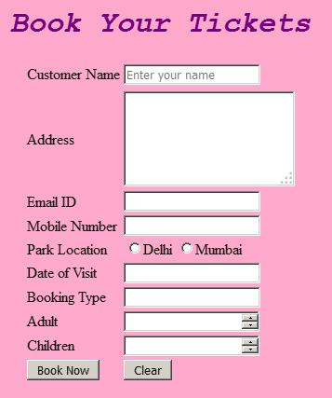

* + - 1. And on providing the values the web page should look as follows :

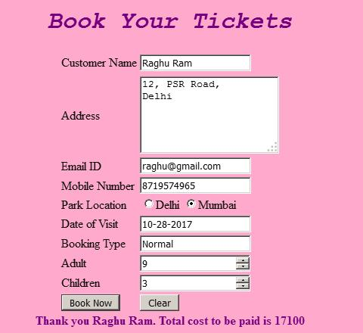

## General Design Constraints

* + - 1. The label name and the component name should be correctly specified as given in the document. Validation of all the fields should be based on HTML 5 (Do not use Javascript). All the fields are mandatory.
      2. For the Styles, do not use Inline CSS.
      3. For Javascript, use getElementsByName or getElementById function to retrieve the values

# Submission

## Code submission instructions

Do not change the code skeleton given as your code will be auto evaluated.

You can validate your solution against sample test cases during the assessment duration.

Your last submitted solution will be considered for detailed evaluation.

Make sure to submit the solution before the specified time limit. Once the time is up, you will not be allowed to submit the solution.

# Change Log

|  |  |  |  |  |
| --- | --- | --- | --- | --- |
|  | Changes Made | | | |
| V1.0.0 | Initial baseline created on <dd-Mon-yy> by <Name of Author> | | | |
| Vx.y.z | <Please refer to the configuration control tool / change item status form if the details of changes are maintained separately. If not, the template given below needs to be followed> | | | |
| **Section No.** | **Changed By** | **Effective Date** | **Changes Effected** |
|  |  |  |  |